### [**A Gingerbread House for Christmas**](https://papercraftetc.blogspot.com/2015/12/a-gingerbread-house-for-christmas.html)

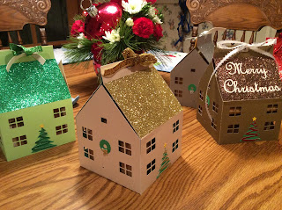

A paper house to hold a delicious cookie gingerbread house.

I love making Gingerbread houses. Here is a box which you can make for storing and gifting a gingerbread house.  
  
I used cardstock, glitter cardstock and chipboard to make this gingerbread house.

My recipe to make gingerbread.

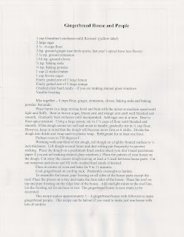

The template to make a cookie gingerbread house. The side measure is 2 7/8 inches x 2 inches. The roof measure is 3 1/2 inches x 2 1/4 inches. The front is 3 inches x 2 inches...with the peak measure of 2 inches. I recommend using graph paper to make your templates.

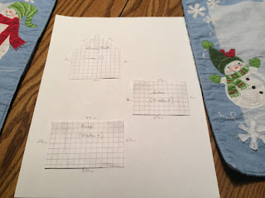

The frosting recipe to hold the house together.

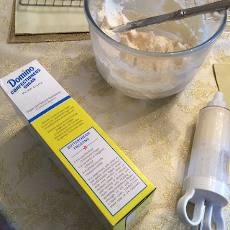

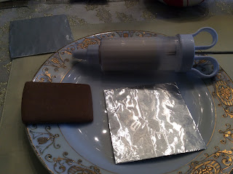

The base is lined with aluminum foil.

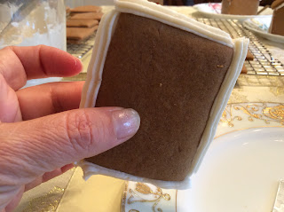

Frost the outer edges of the side piece.

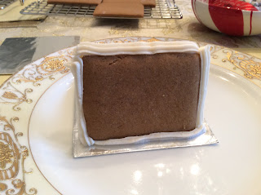

Stand it upright on the aluminum foil.

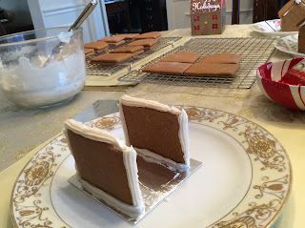

Repeat for the other side.

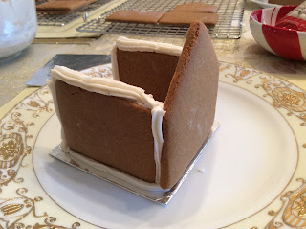

Add the front.

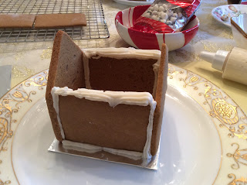

And back.

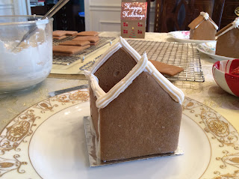

Frost the peaks as shown.

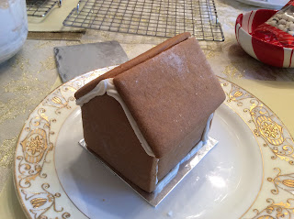

Add the roof pieces.

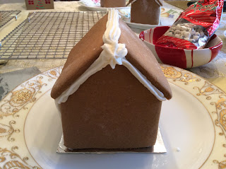

Frost the roof line.

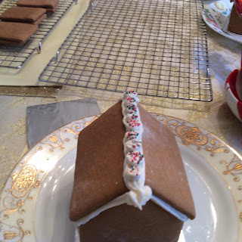

I added some candy decoration.

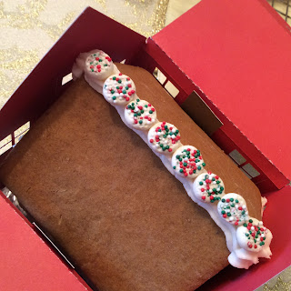

There is a piece of paper which I call the lifter which helps to lift the house out of the box. Add it to the bottom of the aluminum foil before putting the house in the box.

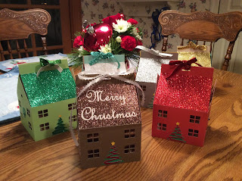

Merry Christmas!